**ADBMS Practical**

Practical 1: DDL operations on Relational Schema

**1.Display name and commission for all the salesmen.**

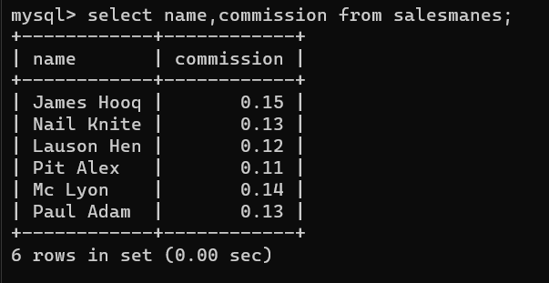

**2.Retrieve salesman id of all salesmen from orders table without any repeats.**

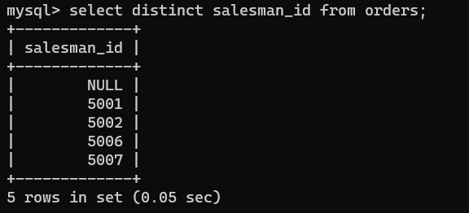

**3.Display names and city of salesman, who belongs to the city of Paris.**

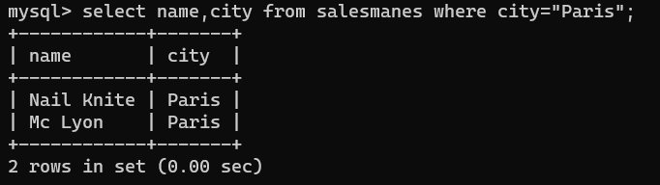

**4.Display all the information for those customers with a grade of 200.**

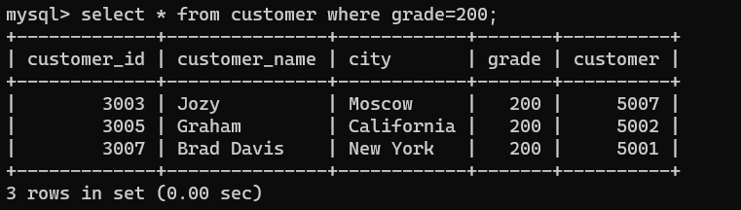

**5.Display the order number, order date and the purchase amount for order(s) which will be delivered by the salesman with ID 5001**

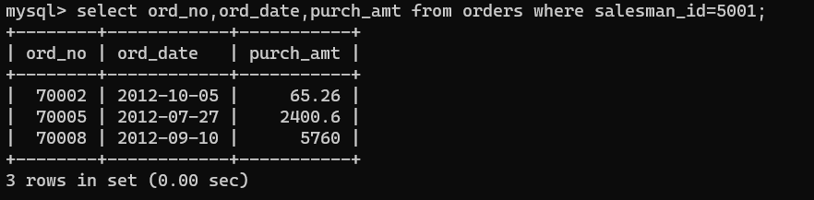**S**

1. **Display all the customers, who are either belongs to the city New York or not had a grade above 100.**

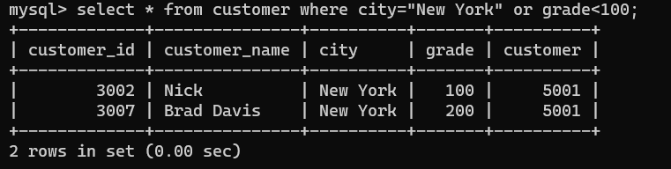

1. **Find those salesmen with all information who gets the commission within a range of 0.12 and 0.14.**

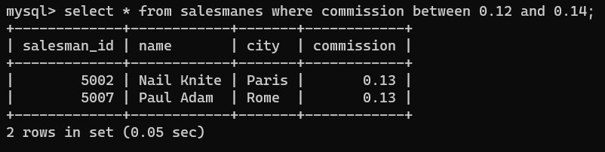

1. **Find all those customers with all information whose names are ending with the letter 'n'.**

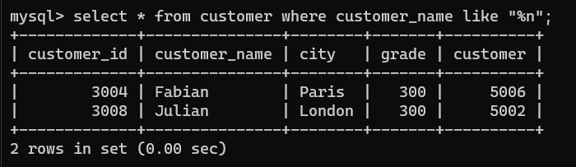

1. **Find those salesmen with all information whose name containing the 1st character is 'N' and the 4th character is 'l' and rests may be any character.**

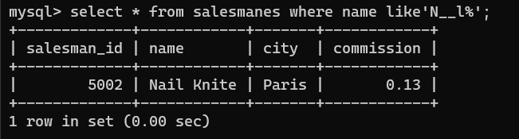

1. **Find that customer with all information who does not get any grade except NULL.**



1. **Find the total purchase amount of all orders.**

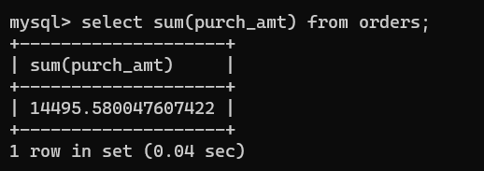

1. **Find the number of salesman currently listing for all of their customers.**

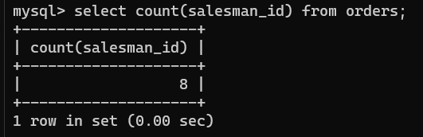

1. **Find the highest grade for each of the cities of the customers.**

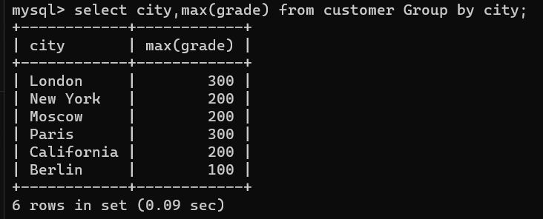

1. **Find the highest purchase amount ordered by each customer with their ID and highest purchase amount.**

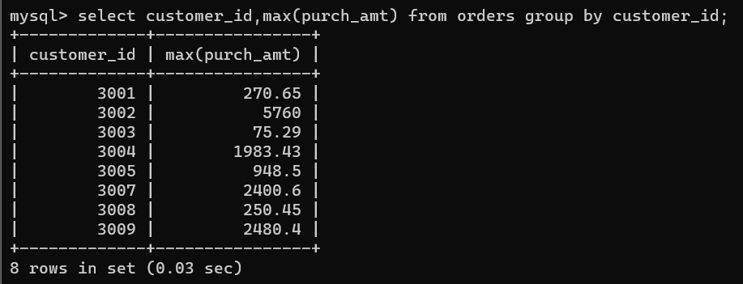

1. **Find the highest purchase amount ordered by each customer on a particular date with their ID, order date and highest purchase amount.**

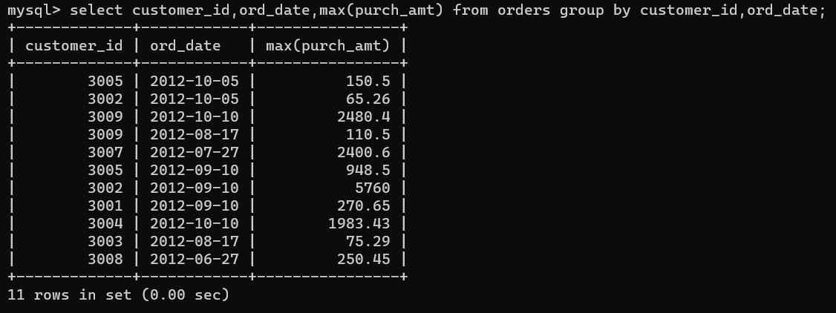

1. **Find the highest purchase amount on a date '2012-08-17' for each salesman with their ID.**

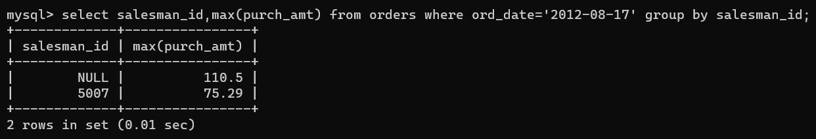

1. **Find the highest purchase amount with their customer ID and order date, for only those customers who have the highest purchase amount in a day is more than 2000.**

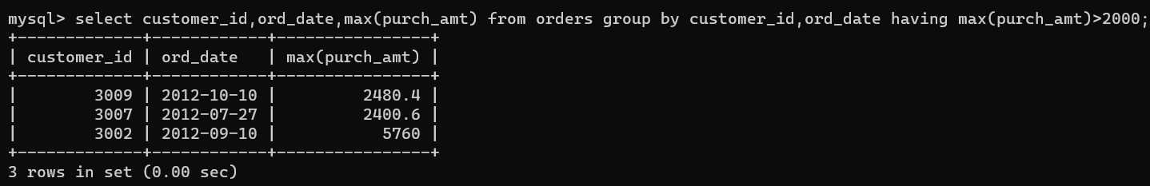

1. **Write a SQL statement that counts all orders for a date August 17th, 2012.**

